SMART EXHAUST FAN

## A MINI-PROJECT REPORT

***Submitted by***

|  |  |
| --- | --- |
| **ROHIT M** | **210701215** |
| **SANTHOSH M** | **210701233** |

***in partial fulfillment of the award of the degree of***

# BACHELOR OF ENGINEERING

**IN**

**COMPUTER SCIENCE ENGINEERING**



# RAJALAKSHMI ENGINEERING COLLEGE, ANNA UNIVERSITY: CHENNAI 600 025

## MAY 2024

**BONAFIDE CERTIFICATE**

Certified that this project **“SMART EXHAUST FAN”** is the bonafide work of **“ROHIT M (210701215) , SANTHOSH M (210701233)”** who carried out the project work under my supervision.

|  |  |
| --- | --- |
| **SIGNATURE** | **SIGNATURE** |
| **Dr. P. Kumar, M.E., Ph.D.,** | **Mrs.ANITHA ASHISHDEEP, M.E, M.Tech** |
| **HEAD OF THE DEPARTMENT** | **SUPERVISOR** |
| **PROFESSOR** | **PROFESSOR** |
| Dept. of Computer Science and Engg, | Dept. of Computer Science and Engg, |
| Rajalakshmi Engineering College,  Chennai - 602105 | Rajalakshmi Engineering College,  Chennai - 602105 |

Submitted to Project Viva-Voce Examination held on

**INTERNAL EXAMINER EXTERNAL EXAMINER**

## ABSTRACT

The IoT Based Smart Exhaust Fan uses the ESP32 microcontroller to develop an intelligent ventilation system that improves the indoor air quality and safety. This system monitors temperature, humidity, and gas levels in the surrounding air by integrating the DHT11 Humidity Temperature Sensor with the MQ-2 Gas/Smoke Sensor. The Blynk Dashboard receives sensor data transmissions, giving users the ability to monitor in real time. A core feature of this project is the automation of the exhaust fan, which is connected to a 12V AC power supply through a relay module. The system automatically turns on the fan to ventilate the area when the MQ-2 sensor detects increased gas levels. This helps to reduce potential hazards and maintain a safe environment. This automated response ensures timely intervention, enhancing both safety and air quality without requiring manual operation. The system provides manual control through the Blynk Dashboard in addition to its automatic features. Users can override the automatic settings to turn the fan on or off according to their personal preferences and specific needs. This dual functionality makes sure that the system can adjust to user needs and react to changes in the environment. This project serves as an example of how IoT technology is being applied to environmental and home safety, showing how smart systems can offer practical solutions to everyday problems. Through the integration of automated control, real-time monitoring, and user flexibility, the IoT Based Smart Exhaust Fan offers the complete solution for controlling indoor air quality, thereby promoting safer and better living environments.

## ACKNOWLEDGEMENT

First, we thank the almighty god for the successful completion of the project. Our sincere thanks to our Chairman **Mr. S. Meganathan, B.E., F.I.E**., for his sincere endeavor in educating us in his premier institution. We would like to express our deep gratitude to our beloved Chairperson **Dr. Thangam Meganathan, Ph.D.,** for her enthusiastic motivation which inspired us a lot in completing this project and Vice Chairman **Mr. Abhay Shankar Meganathan, B.E., M.S.,** for providing us with the requisite infrastructure. We also express our sincere gratitude to our college Principal**, Dr. S.N. Murugesan M.E., PhD.,** and **Dr. Kumar M.E., Ph.D.,** Head of the Department of Computer Science and Engineering and our project guide **Mrs.ANITHA ASHISHDEEP, M.E, M.Tech** for his encouragement and guiding us throughout the project and to our parents, friends, all faculty members and supporting staffs for their direct and indirect involvement in successful completion of the project for their encouragement and support.

**ROHIT M**

**SANTHOSH M**

**TABLE OF CONTENTS**

|  |  |  |
| --- | --- | --- |
| **CHAPTER NO** | **TITLE** | **PAGE NO** |
| **1** | **INTRODUCTION** | 1 |
| **2** | **LITERATURE SURVEY** | 2 |
| 2.1 | EXISTING SYSTEM | 3 |
| **3** | **PROJECT DESCRIPTION** | 4 |
| 3.1 | PROPOSED SYSTEM | 6 |
| 3.2 | REQUIREMENTS | 6 |
| 3.2.1 | HARDWARE REQUIREMENTS | 6 |
| 3.2.2 | SOFTWARE REQUIREMENTS | 6 |
| 3.3 | ARCHITECTURE DIAGRAM | 7 |
| 3.4 | OUTPUT | 8 |
| **4** | **CONCLUSION AND FUTURE WORK** | 11 |
|  | **APPENDICES** | 12 |
|  | **REFERENCE** | 14 |

# CHAPTER 1 INTRODUCTION

Maintaining optimal indoor air quality is crucial for ensuring the health and safety of occupants, particularly in areas such as kitchens, and industrial environments where pollutants and humidity levels can rise rapidly. Traditional exhaust fans often rely on manual operation or simple timers, which lack the capability to respond dynamically to real-time environmental changes. This may result in insufficient ventilation, which could be dangerous for your health because of the accumulation of toxic gasses, smoke, and high humidity. the IoT Based Smart Exhaust Fan project develops a responsive and intelligent ventilation system in order to overcome these barriers.

The ESP32 microcontroller is the central unit behind the entire system; it is a strong and adaptable platform that allows wireless networking and the integration of several sensors. To continuously monitor the parameters of air quality, such as temperature, humidity, and gas levels, the project uses the MQ-2 Gas/Smoke Sensor and the DHT11 Humidity Temperature Sensor. Sensor data is transmitted to the Blynk Dashboard, a user-friendly interface that allows for real-time monitoring of environmental conditions. When high gas levels are detected, the system immediately turns on the exhaust fan through a relay module, improving safety and ensuring immediate ventilation. Furthermore, the Blynk Dashboard offers manual control options that let users override preset settings and adjust the fan according to their own needs .

# CHAPTER 2 LITERATURE SURVEY

[1]These days, the majority of homes, offices, schools, factories, and other businesses have at least one exhaust fan. For some people, it has become a standard tool or equipment. An exhaust fan's functions include temperature management, moisture removal, and odour elimination.

[2]Exhaust fan can cool downs a space quickly, which have become too hot. If an area get too hot, people body will start to giving some Symptoms like muscle cramps and nausea. These are early warning signs of heat exhaustion or heat stress. If a body get hotter than 40°C, It starts shutting down and sees damage to vital organs like the kidneys and brain.

[3]Air quality is important in human life. Each day an adult breathes 15000 liter of air.

[4]At the point when we inhale contaminated air poisons get into our lungs, they can enter the bloodstream and be carried to our internal organs such as the brain. This can cause extreme medical issues, for example, asthma, cardiovascular diseases and even cancer and reduces the quality and number of years of life. So it is important for us to know the air around us is safe to breathe.

[5]Most of worker who working in closed room with heavy machine running around in it, have high possibility of suffering serious health problems. Smoke and toxic gas from the machine and tools which used in closed room can cause the gas to trap in. This causes the people or the workers in the room to breathe in the toxicities air. Without a proper exhaust fan the toxicities air cannot been remove in closed space.

[6]Although, there is a lot of technology improvement in the exhaust fan still it is not smart enough. There are a lot of concerns when dealing with “traditional” exhaust fan especially in the operations of the exhaust fans. The real support for this problem is due to the inability of the user to define the most appropriate temperature and air quality in a space. The user will have difficulty to sense temperature and air quality directly by their body. Besides that, because of this difficulty the user will forget to turn ON the device or let the device turn ON for very long period time. This will cost waste in power consumption and inefficient performance from the device.

[7]IoT based smart exhaust fan is introduced which can control the exhaust fan depending on the temperature and air quality in a space without any human interference. This device uses gas sensor and temperature sensor to detect and turning the exhaust fan ON to push the air or gas outdoor. This IoT based smart exhaust fan is very useful if it is fixed in factories, industries, office, school, and also houses. Therefore, this project aims to designand build an IoT based smart exhaust fan which can turn ON and OFF automatically depend on temperature and air quality.Then, the system is able to measure and record data for data collection of temperature and air quality in a spaceand finally, the IoT system was implementedin the prototype.

# EXISTING SYSTEM

Traditional exhaust fans are primarily manual, requiring user intervention to operate. These systems lack the ability to respond dynamically to real-time changes in environmental conditions such as gas levels, temperature, and humidity. Manual exhaust fans depend on users to turn them on or off, often resulting in either over-ventilation, which wastes energy, or under-ventilation, which can lead to poor air quality and increased health risks. Additionally, existing systems typically do not provide any form of remote monitoring or control, limiting their usability and convenience. Consequently, traditional exhaust fans do not effectively address the need for adaptive, real-time air quality management, highlighting the necessity for smarter, IoT-integrated solutions that can enhance both safety and energy efficiency in modern homes and industrial environments.

# CHAPTER 3 PROJECT DESCRIPTION

32

Display in the App

### Figure 1

This system aims at providing Smart Exhaust Fan using ESP32 Dev Module and various other sensors to sense the data. Necessary packages are installed.

The interface between ESP32 Dev Module and the other sensors that were mentioned earlier is enabled by giving the necessary connections using GPIO pins.

## The IoT-based smart exhaust fan system begins its operation by continuously monitoring indoor environmental conditions using a suite of sensors. These sensors collect data on temperature, humidity, and air quality (including pollutants like carbon dioxide and volatile organic compounds). The gathered data is sent to a central microcontroller, which acts as the brain of the system. This microcontroller processes the sensor inputs and applies a predefined algorithm to determine if the current environmental conditions exceed the user-set thresholds. For instance, if the humidity sensor detects levels above 65% or if the air quality sensor measures high pollutant levels, the microcontroller signals the exhaust fan to turn on, initiating ventilation to restore optimal air conditions.

## Simultaneously, the system's Wi-Fi module ensures connectivity to the internet, enabling real-time data transmission to a cloud server. This connection allows users to remotely monitor and control the exhaust fan via a mobile application. The app provides a user-friendly interface displaying current environmental data and system status, and it allows users to set or adjust operational parameters. For example, users can set specific thresholds for humidity or pollutants and schedule operational times.

## PROPOSED SYSTEM

The proposed system for an IoT-based smart exhaust fan integrates advanced technologies to enhance the efficiency, functionality, and user convenience of traditional exhaust fans. This smart exhaust fan system is designed to automatically control air quality, humidity, and temperature within a room or building, ensuring optimal indoor environmental conditions. By leveraging Internet of Things (IoT) technology, this system enables real-time monitoring and control through connected devices such as smartphones, tablets, or computers. Additionally, the smart exhaust fan can be controlled manually via a mobile application. The app provides users with real-time updates on indoor air quality and allows them to adjust fan settings remotely. This feature is particularly useful for homeowners who wish to control the ventilation system while away from home, ensuring a comfortable environment upon their return.

## REQUIREMENTS

### HARDWARE REQUIREMENTS

* + - * ESP32 Dev Module
      * Power Supply
      * Wi-Fi
      * DHT11 sensor
      * MQ-2 Sensor
      * Breadboard
      * 12V DC Fan
      * Laptop

### SOFTWARE REQUIREMENTS

* + - * Arduino IDE
      * Blynk App

## ARCHITECTURE DIAGRAM

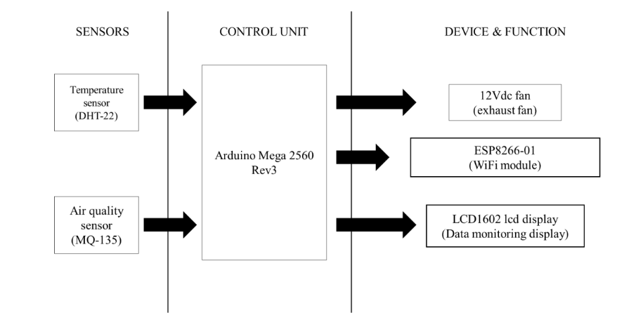

Blynk App

32

ESP32 Dev Module

02)

11



### Figure 2

## Figure 2 depicts the working flow of an IoT-based smart exhaust fan system, illustrating the integration of sensors, a control unit, and connected devices. The system includes a temperature sensor (DHT-11) and an air quality sensor (MQ-02) that monitor environmental conditions and send data to the ESP32 development module, which serves as the control unit. The ESP32 processes this data and, based on predefined thresholds, controls a 12V DC exhaust fan to regulate air quality and temperature. Additionally, the ESP32 incorporates a Wi-Fi module to connect to the internet, enabling remote data monitoring and control via the Blynk app. The Blynk app provides a user-friendly interface for displaying real-time sensor data and managing the exhaust fan's operation, ensuring efficient and convenient environmental control.

## 

## OUTPUT

### Figure 3

Figure 3 is the output of real time updation of the data of sensors like MQ-02 and DHT11 sensors getting displayed in the Blynk IoT website.

### CONNECTIONS:

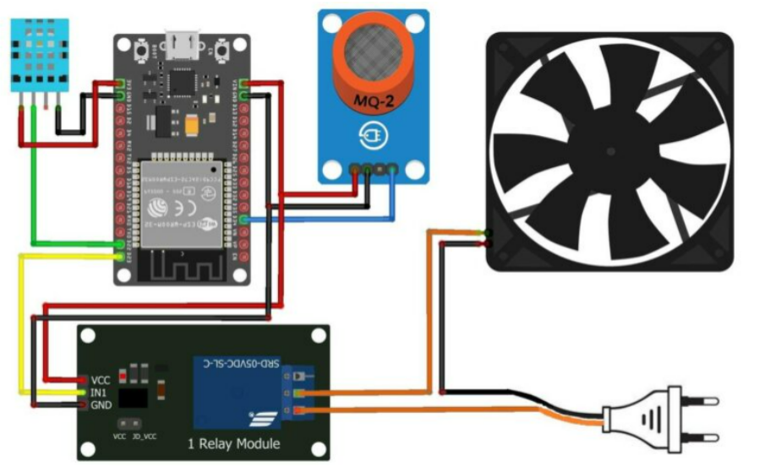

**Figure 4**

Figure 4 shows the connections made to the sensors and the fan to interface with the ESP32 Dev module. The connections are provided as specified in the architecture.

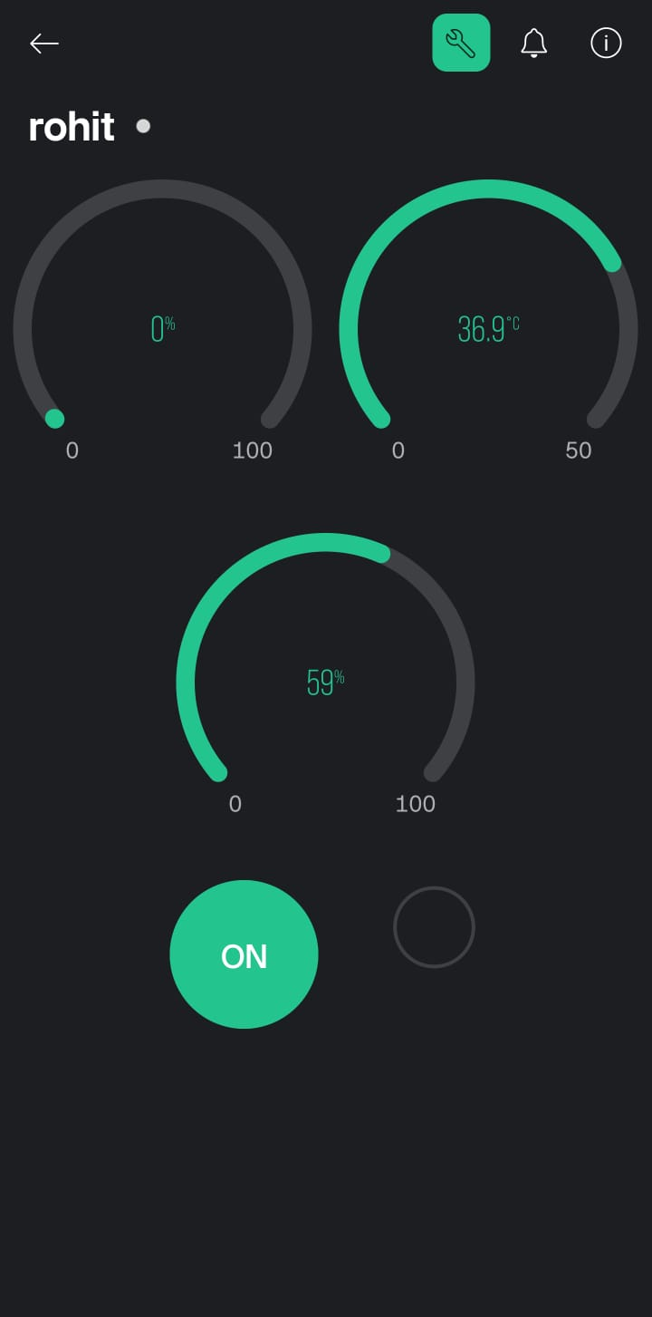

### Figure 5

Figure 5 shows the output of the value from the sensors in the Blynk App.

## CHAPTER 4 CONCLUSION AND FUTURE WORK

The IoT Based Smart Exhaust Fan project successfully demonstrates the integration of IoT technology to enhance indoor air quality and safety. The system effectively monitors environmental conditions and automatically controls the exhaust fan, offering a responsive and efficient solution. Real-time data transmission to the Blynk Dashboard allows for continuous monitoring and manual control, offering flexibility and user convenience. Through automated air quality monitoring, this project demonstrates how the Internet of Things can be used to create smarter home environments that guarantee safer and healthier living spaces.

Future enhancements for the Smart Exhaust Fan IoT project could include advanced features such as integration with existing smart home ecosystems like Google Home or Amazon Alexa for seamless voice control. By analyzing consumption trends and environmental data, machine learning algorithms could be used to enhance predictive maintenance and energy efficiency. Additionally, expanding the system to include more sophisticated sensors and actuators could enhance its capabilities. Integrating more control choices and in-depth analytics to the user interface would improve it and provide users more information and control over their interior environment. Installing renewable energy sources, such solar panels, could also lessen the system's environmental impact and increase sustainability.

**APPENDIX I**

#define BLYNK_TEMPLATE_ID "TMPL6YAS5_ss3"

#define BLYNK_TEMPLATE_NAME "IoT Smart Exhaust Fan"

#define BLYNK_PRINT Serial

#include <WiFi.h>

#include <BlynkSimpleEsp32.h>

#include "DHT.h"

// Blynk and WiFi credentials

const char auth[] = " 3e7we2InkGx0znZEse4eW5oHoYD1f54H";

const char ssid[] = "Hello";

const char pass[] = "1234567890";

// Pin configuration

#define DHTPIN 22

#define DHTTYPE DHT11

const int gasSensorPin = 34; // Gas sensor pin

const int relayPin = 23; // Relay module pin

const int gasThreshold = 20; // Gas level threshold for triggering the relay

DHT dht(DHTPIN, DHTTYPE); // Initialize DHT sensor

bool manualMode = false; // Flag to track if the relay is in manual mode

void setup()

{

Serial.begin(115200); // Start serial communication at 115200 baud rate

dht.begin(); // Initialize DHT sensor

Blynk.begin(auth, ssid, pass); // Connect to Blynk using WiFi

pinMode(relayPin, OUTPUT); // Set relay pin as output

pinMode(gasSensorPin, INPUT); // Set gas sensor pin as input

digitalWrite(relayPin, LOW); // Ensure relay is off initially

delay(2000); // Wait for 2 seconds before proceeding

}

// Function to handle manual relay control from Blynk app

BLYNK_WRITE(V4)

{

int relayControl = param.asInt(); // Get value from Blynk app

manualMode = (relayControl == 1); // Set manual mode based on app input

if (manualMode)

{

digitalWrite(relayPin, HIGH); // Turn on relay in manual mode

}

else

{

digitalWrite(relayPin, LOW); // Turn off relay when exiting manual mode

}

Blynk.virtualWrite(V3, relayControl); // Update relay status on Blynk

}

void loop()

{

Blynk.run(); // Run Blynk

int sensorValue = analogRead(gasSensorPin); // Read gas sensor value

int gas_percentage = map(sensorValue, 0, 4095, 0, 100); // Convert to percentage

float humidity = dht.readHumidity(); // Read humidity from DHT sensor

float temperature = dht.readTemperature(); // Read temperature from DHT sensor

// Check if sensor readings are valid

if (isnan(humidity) || isnan(temperature))

{

Serial.println(F("Failed to read from DHT sensor!"));

return;

}

// Print sensor values to the Serial Monitor

Serial.print("Humidity: ");

Serial.print(humidity);

Serial.println("%");

Serial.print("Temperature: ");

Serial.print(temperature);

Serial.println("°C ");

Serial.print("Gas sensor value: ");

Serial.println(sensorValue);

Serial.print("Gas Percentage: ");

Serial.print(gas_percentage);

Serial.println("%");

Serial.println();

// Automatic control logic based on gas levels

if (!manualMode)

{

if (gas_percentage > gasThreshold)

{

digitalWrite(relayPin, HIGH); // Activate relay if gas above threshold

Blynk.virtualWrite(V3, HIGH); // Update Blynk app

}

else

{

digitalWrite(relayPin, LOW); // Deactivate relay if gas below threshold

Blynk.virtualWrite(V3, LOW); // Update Blynk app

}

}

// Send sensor values to Blynk

Blynk.virtualWrite(V0, gas_percentage); // Send gas percentage

Blynk.virtualWrite(V1, temperature); // Send temperature

Blynk.virtualWrite(V2, humidity); // Send humidity

delay(1000); // Wait for a second before next loop iteration

}

**REFERENCE**

1. Housh, W. (2020, March 12). What is an Exhaust Fan?: HVAC.com®. Retrieved November 03, 2020, from <https://www.hvac.com/blog/exhaust-fans-essential-home-comfort/>
2. Rosman, J. (2020, June 02). What Happens To Our Bodies When It's Hot Out?Retrieved November 03, 2020, from <https://www.opb.org/news/article/hot-tempatures-portland-body-heat-what-happens/>
3. Why is air quality so important?(n.d.). Retrieved November 03, 2020, from <https://www.transportenvironment.org/what-we-do/air-quality-and-transport/why-air-quality-so-important>
4. Here, P. (2020, April 06). Gas Poisoning-Symptoms, Causes and Treatments. Retrieved November 03, 2020, from <https://healthtian.com/gas-poisoning/>
5. Givoni, B. (2009, November 04). Indoor temperature reduction by passive cooling systems. Retrieved October 30, 2020, from <https://www.sciencedirect.com/science/article/abs/pii/S0038092X09002357>
6. Kurniawan, A. (2017). Building Your Own IoT Using Arduino and .NET. Arduino Programming with .NET and Sketch, 109-163. doi:10.1007/978-1-4842-2659-9_5
7. Mohite, S., Adsule, S., Patil, R., &amp; Dhawas, N. (2020). Automatic Temperature Based Fan Speed Controller Using Arduino. SSRN Electronic Journal. doi:10.2139/ssrn.3645388